**ASSIGNMENT-01**

**SMART HOME AUTOMATION**

**CONCEPT:**

* Here, the led, bulb and the vibrator motor are turned on using the IR remote
* For each element to be turned on different numbers are used on the remote.
* An IR temperature sensor is also used
* It is coded in such away that different elements are operated when the signal is passed from the remote.

**BLOCK DIAGRAM:**

INPUT SIGNAL FROM THE IR REMOTE

VIBRATOR SENSOR

BULB

LED

ARDUINO

UNO

**CODE:**

#include <IRremote.h>  
int RECV_PIN = 5;  
int i=0;  
int j=0;  
int k=0;  
IRrecv irrecv(RECV_PIN);  
decode_results results;  
void setup() {  
  Serial.begin(9600);  
  irrecv.enableIRIn();  
  pinMode(13,OUTPUT);  
   pinMode(9,OUTPUT);  
   pinMode(11,OUTPUT);  
}  
void loop() {  
  //digitalWrite(13,LOW);  
  if (irrecv.decode(&results)) {  
    Serial.println(results.value, HEX);  
    if(results.value==0xFD30CF)  
    {  
       i++;  
        int x=i%2;  
      digitalWrite(13,x);  
       }  
    else if(results.value==0xFD08F7)  
    {  
       j++;  
        int y=j%2;  
      digitalWrite(9,y);  
       }  
    else if(results.value==0xFD8877)  
    {  
       k++;  
        int z=k%2;  
      digitalWrite(11,z);  
       }  
    irrecv.resume();  
  }  
  delay(100);  
}

**OUTPUT:**

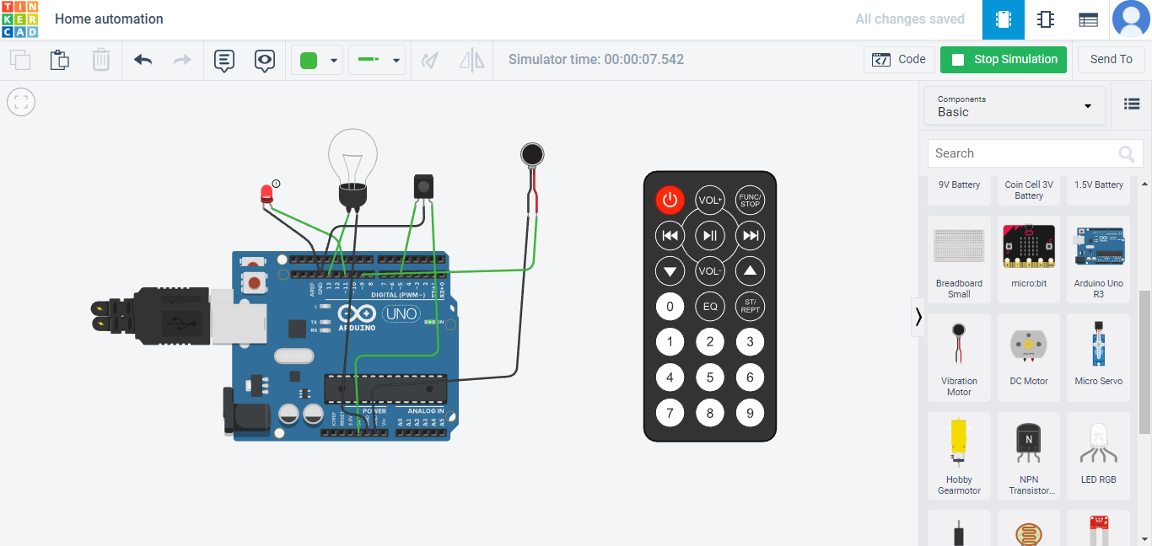

LED is glown when 2 is pressed in remote

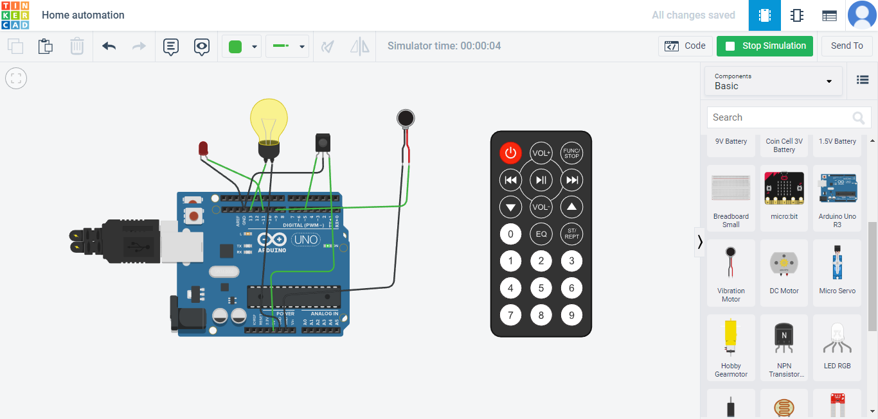

Bulb is blown when 0 is pressed in remote

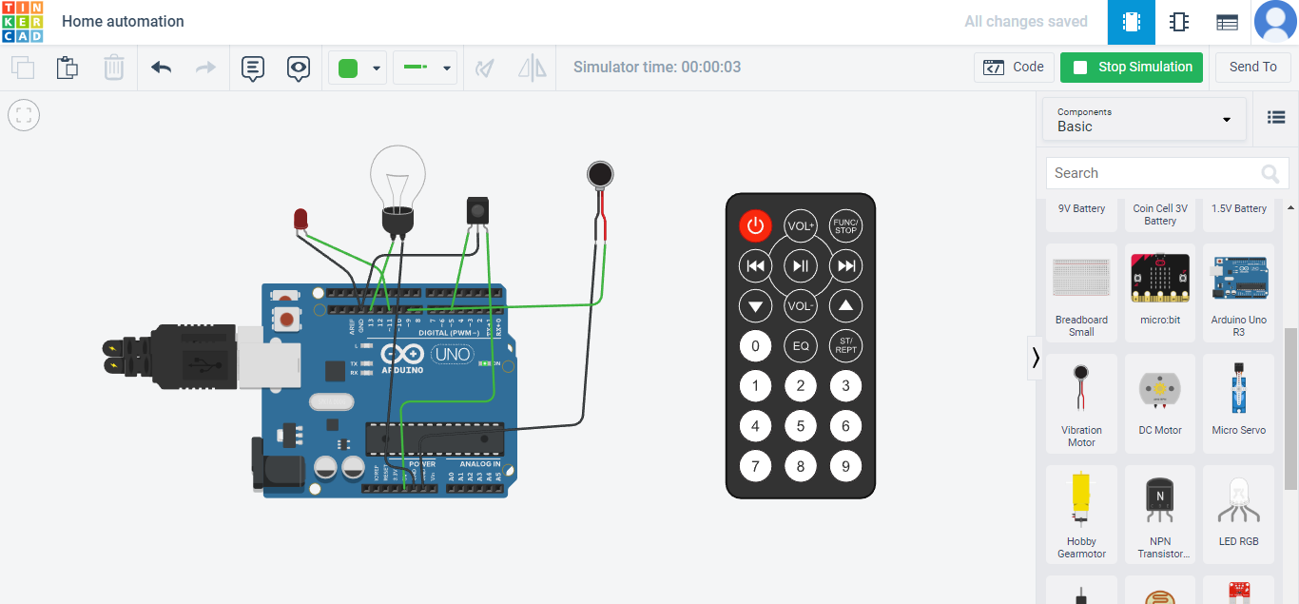

when no input is given